**A Research Paper on Analysis of Travel Behaviour: A Study on Route Optimization Considering Time, Money and City Ratings as Constraints**

Prachi Anand

C.V Raman Global University

Computer Science and Engineering

Bihar, India

2201020103@cgu-odisha.ac.in

Sourav Raut

C.V Raman Global University

Computer Science and Engineering

Jharkhand, India

2201020133@cgu-odisha.ac.in

Sarang Kumar Singh

C.V Raman Global University

Computer Science and Engineering

Bihar, India

2201020123@cgu-odisha.ac.in

Sudeep Swarnakar

C.V Raman Global University

Computer Science and Engineering

Jharkhand, India

2201020138@cgu-odisha.ac.in

Sofia Akhtar

C.V Raman Global University

Computer Science and Engineering

Jamshedpur, India

2201020130@cgu-odisha.ac.in

Sugam Shaw

C.V Raman Global University

Computer Science and Engineering

Kolkata, India

2201020139@cgu-odisha.ac.in

***Abstract*—** Within the expansive domain of tourism, ensuring optimal travel experiences stands as a paramount objective, pivotal to guaranteeing visitor satisfaction and fostering destination exploration. The following case study intricately examines the development of an advanced tourism planner meticulously designed to furnish tailored tour guidance to visitors navigating within a specified state. This sophisticated planner seamlessly integrates an array of factors, encompassing the distances between cities, optimal time allocations for each city visit, and subjective city ratings, with the aim of methodically crafting personalized itineraries.

Employing sophisticated algorithms for the purpose of optimizing route planning and conscientiously considering visitor preferences, the tourism planner aspires not only to elevate the quality of travel experiences to unprecedented levels but also to achieve pivotal objectives such as maximizing time efficiency and illuminating the diverse array of attractions within the state. This case study serves as a comprehensive exploration into the contemporary application of data-driven methodologies within the field of tourism management. It underscores the seamless integration of cutting-edge technology and the enduring principles of hospitality, collectively contributing to the creation of profoundly memorable and fulfilling journeys for discerning travelers.

***Keywords—*** ***tourism, optimal travel, visitor satisfaction, destination exploration, advanced planner, tailored guidance, specified state, city distances, optimal time, subjective ratings, personalized itineraries, algorithms, route planning, preferences, elevate experiences, maximize efficiency, diverse attractions, data-driven methodologies, technology, hospitality, memorable journeys, discerning travelers, research paper***

**INTRODUCTION**

Efficient travel planning plays a pivotal role in enhancing tourism experiences by optimizing routes, maximizing attractions visited, and minimizing resource expenditure. In this paper, we delve into the realm of heuristic function-based algorithms for designing a robust travel planner. Heuristic functions provide a powerful framework for generating optimized travel itineraries by leveraging intelligent search techniques and problem-solving strategies.

Our research explores the application of three distinct heuristic function-based algorithms: Ant Colony Optimization, A* algorithm, and Genetic Algorithm. Each algorithm offers unique strengths and approaches to travel planning, aiming to address various constraints and objectives inherent in the task.

Ant Colony Optimization (ACO) draws inspiration from the foraging behavior of ants to identify optimal routes through a graph-based representation of travel destinations. ACO excels in finding near-optimal solutions while accommodating factors such as time, cost, and distance.

The A* algorithm, renowned for its efficiency and optimality, employs a combination of heuristic estimation and search strategies to navigate through the travel network. By intelligently prioritizing nodes based on heuristic values, A* algorithm swiftly identifies the most promising paths, minimizing travel time and resource utilization.

Genetic Algorithm (GA) takes inspiration from evolutionary principles to iteratively refine travel itineraries, simulating the process of natural selection and genetic variation. GA offers a versatile approach to travel planning, capable of accommodating diverse constraints and preferences while optimizing routes over multiple iterations.

Through our exploration of these heuristic function-based algorithms, we aim to uncover their respective capabilities, limitations, and suitability for designing efficient travel planners. By evaluating their performance in real-world scenarios and comparing results, we seek to provide valuable insights into the application of heuristic techniques in travel planning and tourism optimization.

In the subsequent sections of this paper, we delve into the methodologies employed, experimental setups, results obtained, and analyses conducted for each algorithm. Through this comprehensive investigation, we aim to contribute to the advancement of travel planning algorithms and their practical implementation in enhancing tourism experiences.

# LITERATURE REVIEW

***The Need for Multi-Criteria Travel Planning***

Travelers today have diverse needs, and travel planning tools need to evolve to reflect that. This literature review explores existing research on travel planning algorithms, highlighting their strengths and limitations, to pave the way for our proposed algorithm that considers time constraints, city ratings, and cost.

***Traditional Approaches and Their Shortcomings***

Traditional approaches often focus on a single factor. Dijkstra's algorithm, for example, finds the fastest route between locations, neglecting user preferences and the potential enjoyment of the journey [1]. Multi-modal routing expands options beyond roads but may prioritize minimizing travel time or cost without considering scenic routes or desired city experiences [2].

***Personalization Efforts and Their Limitations***

Some approaches attempt personalization. Genetic algorithms can create personalized itineraries based on budget, time, and desired activities [3]. However, they can be computationally expensive for large datasets and might not explicitly factor in city ratings. Machine learning analyzes user data to recommend routes and destinations, but may require extensive training data and might not explicitly address cost constraints [4].

***Recent Advancements and Remaining Gaps***

Recent advancements like dynamic routing improve efficiency by incorporating real-time factors that can impact travel time [5]. However, they might not address user preferences for city experiences or budget limitations. Multi-objective optimization offers flexibility by allowing users to prioritize their preferences, but existing approaches might require complex algorithms and significant user input [6].

There's a clear gap in algorithms that consider all three factors: time constraints, city ratings, and cost. Our proposed algorithm aims to bridge this gap by leveraging a heuristic function framework with weighted edges that account for all three, providing travelers with a more comprehensive and user-centric approach to travel planning..

# METHODOLOGY

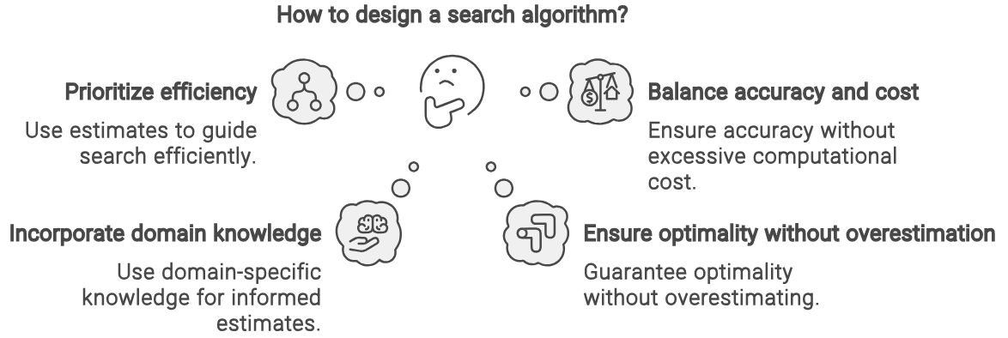

**HEURISTIC FUNCTION:**

A heuristic function is a function that estimates the cost of reaching the goal from a given state in a search problem. It provides a rough estimate of how close a state is to the goal state without necessarily being exact. The key characteristics of a good heuristic function are admissibility and consistency.

**A* Search Algorithm**:

In A*, the heuristic function is typically denoted as h(n). It estimates the cost from the current state (node) to the goal state. A* combines the actual cost from the start node to the current node denoted as (𝑛)with the heuristic estimate h(n) to make informed decisions about which nodes to explore next.The key property of the heuristic function in A* is that it should be admissible, meaning it never overestimates the true cost to reach the goal from the current state.

def astar(start, goal):

    open_set = [start]

    while open_set:

        current = open_set.pop(0)

        if current == goal:

            return current

        open_set.extend(get_neighbors(current))

    return None

**Genetic Algorithms:**

In genetic algorithms, a heuristic function is used to evaluate the quality of candidate solutions (individuals) in the population.This heuristic function is problem-specific and often involves calculating a fitness score for each individual, which represents how well it solves the problem or how close it is to the optimal solution.The genetic algorithm uses the fitness scores provided by the heuristic function to guide the selection, crossover, mutation, and replacement operations in the evolutionary process. Harnessing these fitness scores, the genetic algorithm orchestrates the selection, crossover, mutation, and replacement operations throughout the evolutionary process. This iterative refinement, guided by the heuristic function's insights, empowers the algorithm to continually hone in on increasingly proficient solutions, thus driving the optimization journey towards achieving the desired outcomes.

def genetic_algorithm(t,p,m,g):

 p=[[random.randint(0,1)for _ in t]for _ in range(p)]

 for _ in range(g):

  p.sort(key=lambda x:sum(a==b for a,b in zip(x,t)),reverse=True)

  if sum(a==b for a,b in zip(p[0],t))==len(t):return p[0]

  np=p[:2]

  while len(np)<p:

   p1,p2=random.choices(p[:10],k=2)

   cp=random.randint(1,len(p1)-1)

   c1,c2=p1[:cp]+p2[cp:],p2[:cp]+p1[cp:]

   for c in(c1,c2):

    for i in range(len(c)):

     if random.random()<m:c[i]=1-c[i]

   np.extend([c1,c2])

  p=np

**Ant Colony Optimization (ACO):**

In ant colony optimization, the heuristic function is used by individual ants to make decisions about which path to choose when traversing the graph. This heuristic function often combines information about the pheromone trails deposited by other ants and additional problem-specific information, such as distance or attractiveness of the edges. Ants use this heuristic function to probabilistically select paths, favoring those with higher pheromone concentrations or other desirable properties

function ACO(graph, ants, iterations):

    Initialize pheromones

    Repeat iterations:

        For each ant:

            Place ant on random start node

            While ant not at goal:

                Move ant based on probabilities

                Update pheromone on traversed edge

            Update global best if better solution found

    Return global bes

Summary:

Heuristic functions play a crucial role in guiding search algorithms towards optimal or near-optimal solutions efficiently.

* In A*, the heuristic function estimates the cost from the current state to the goal state.
* In genetic algorithms, the heuristic function evaluates the quality of candidate solutions.
* In ant colony optimization, the heuristic function helps ants make decisions about path selection during traversal.

**REASEARCH DESIGN**

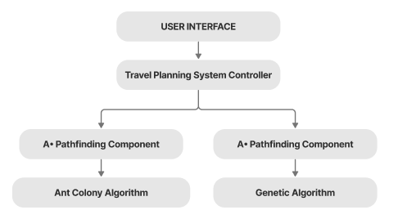

Figure: Structural Architecture

The image illustrates the architecture of a travel planning algorithm. It begins with a User Interface, through which users interact with the system. The central component is the Travel Planning System Controller, which manages the entire travel planning process.

* Within the controller, there are two A* Pathfinding Components. The first component utilizes the A* pathfinding algorithm to find the shortest distance between cities. It further integrates an Ant Colony Algorithm, suggesting the use of ant colony optimization to refine the path between cities for efficiency.
* The second A* Pathfinding Component also uses the A* algorithm but focuses on planning within cities. It incorporates a Genetic Algorithm, indicating the use of genetic optimization techniques to plan the sequence of places to visit within each city.

Overall, this architecture combines A* pathfinding, ant colony optimization, and genetic algorithms to create an advanced travel planning system capable of efficiently determining routes between cities and optimizing itineraries within each city for a seamless travel experience.

## DATA COLLECTION

For our research on finding the best route between cities considering time constraints and city ratings, we collected data from two CSV files. These CSV files contain essential information about cities, including their ratings, time taken to explore each city,cost in travelling and travel times between pairs of cities.

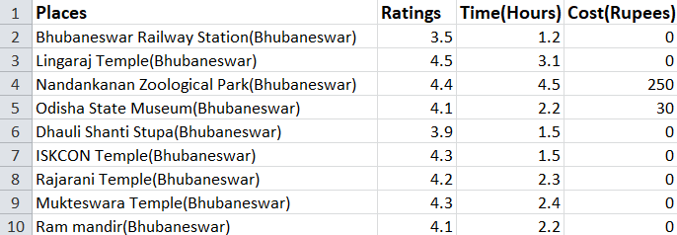

Figure: First csv file

This file contains information about the ratings of different cities along with the time required to explore each city. The data in this file helps us understand the attractiveness of each city and the time investment required for exploration.

The structure of the CSV file is as follows:

Column 1: City Name

Column 2: City Rating (e.g., on a scale of 1 to 5)

Column 3: Time Taken to Explore the City (in hours)

Column 4: Cost of Exploration (in Indian Rupees)

**Travel Time’s CSV File:**

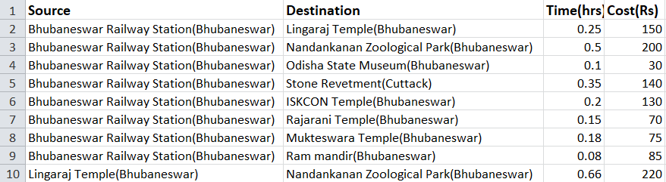

Figure: Second csv file

This file contains information about the travel times between pairs of cities. It helps us construct a graph representing the connectivity between cities and the time required to travel between them.

The structure of the CSV file is as follows:

Column 1: Source City

Column 2: Destination City

Column 3: Travel Time between Source and Destination (in hours )

Column 4: Cost of Travel between Source and Destination (in Indian Rupees)

We utilized the data from these CSV files to construct a graph representation of the city network. The graph was constructed using an adjacency list as a dictionary, where each city is represented as a vertex, and the travel times between cities are represented as weighted edges.

Additionally, we integrated the city ratings and exploration times into the graph to consider them during the path-finding process.

Assumptions might include considering symmetric travel times (i.e., the time to travel from city A to city B is the same as the time to travel from city B to city A) and handling missing data appropriately (e.g., assigning default values or excluding incomplete entries).

**RESULTS**

**GRAPH OF 4 CITIES WHICH IS USED AS INPUT IN OUR CODE :**

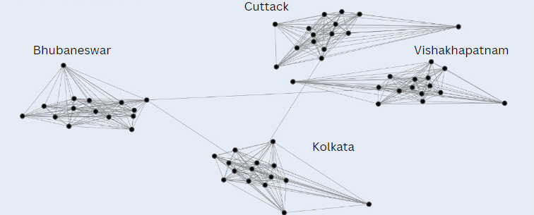

Figure: Graph showing the connections

The image presents a comprehensive network graph illustrating the transportation and tourist routes within four prominent cities in Eastern India: Bhubaneswar, Cuttack, Kolkata, and Visakhapatnam. This graphical representation provides insights into the connectivity and accessibility of key landmarks, tourist attractions, and transportation hubs in the region.

**City-wise Analysis**

Bhubaneswar: Bhubaneswar, the capital city of Odisha, is depicted with a total of 15 nodes representing significant landmarks and tourist attractions. These include Bhubaneswar Railway Station, ISKCON Temple, Lingaraj Temple, and others.

Cuttack: Cuttack, a historic city situated near Bhubaneswar, is characterized by 15 nodes within the graph. These nodes include Cuttack Chandi Temple and Cuttack Junction Railway Station, among others.

Kolkata: The vibrant metropolis of Kolkata is represented with 15 nodes, highlighting iconic landmarks such as Howrah Junction Railway Station, Victoria Memorial, and Dakshineswar Kali Temple and others.

Visakhapatnam: Visakhapatnam, a coastal city known for its scenic beauty, is characterized by 15 nodes within the graph. These nodes include Visakhapatnam Railway Station, Araku Valley, INS Kursura Submarine Museum and others.

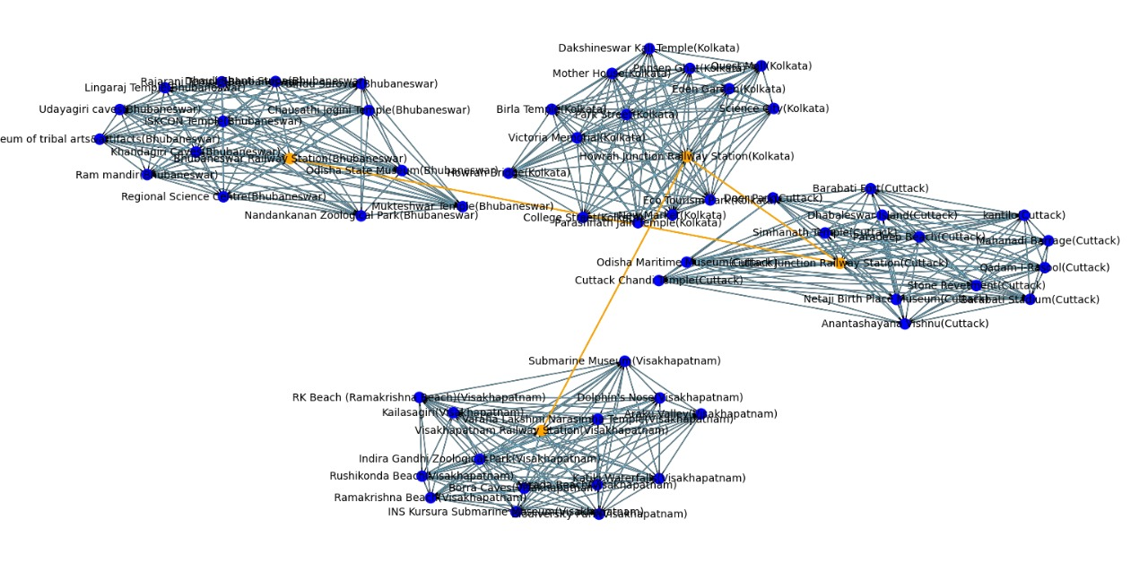

Figure: Graph showing the details for the cities

**Insights and Analysis :** The graph illustrates a transportation network consisting of railway stations (depicted in yellow) and various landmarks or destinations (depicted in blue) in four cities. The cities represented in the graph are not explicitly labeled, but based on the landmarks mentioned, they include Kolkata, Bhubaneswar, Cuttack, and Visakhapatnam.

1. Yellow Nodes (Railway Stations): These nodes represent the railway stations within the four cities. Railway stations are crucial transportation hubs that connect different regions and facilitate travel by train.
2. Blue Nodes (Landmarks or Destinations): These nodes represent notable landmarks, attractions, or destinations within the respective cities. They may include tourist spots, historical sites, cultural attractions, or other points of interest.
3. Navy Edges (Connections): The edges between nodes depict connections or routes between railway stations and nearby landmarks. They signify transportation links, such as railway lines or roads, that enable travel between different locations within the cities.

**Interpretation:** The graph provides a visual representation of the connectivity between railway stations and key landmarks within the four cities.It offers insights into the accessibility and transportation options available for travelers visiting or moving within these cities.The visualization aids in route planning, identifying transportation corridors, and understanding the spatial distribution of landmarks relative to railway stations.

## ANT COLONY OPTIMIZATION (ACO) FOR ROUTE OPTIMIZATION

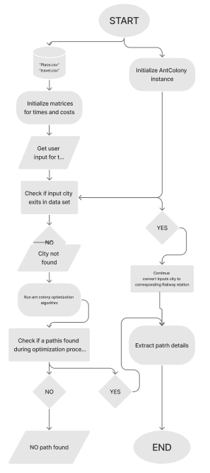Figure: Flowchart of Ant Colony Optimization

This flowchart outlines the iterative process of an Ant Colony Optimization (ACO) algorithm for finding an optimal route between a starting point and a destination. It mimics the behavior of real ant colonies to identify the path with the highest desirability (shortest distance, lowest cost, etc.).

**Initialization:**

1. **Problem Definition:** The flowchart starts with defining the problem, which likely involves specifying:
   * **Starting Point:** The origin city from which the route begins.
   * **Destination:** The final city where the route terminates.
   * **Cities/Locations:** A list of all cities or locations to be considered during route planning.
   * **Distance Matrix:** A table or data structure indicating the distances between each pair of cities.
2. **Pheromone Initialization:** An initial amount of pheromone is placed on all edges (connections) between cities. Pheromone represents desirability - higher pheromone levels indicate a more favorable path for the ants to follow.

**Main Loop:**

The core optimization process occurs within this loop, iterating until a satisfactory solution is found.

1. **Ant Placement:** A predetermined number of artificial ants are placed on the starting city.
2. **Ant Movement:** Each ant iteratively constructs its route by probabilistically choosing the next city to visit based on two factors:
   * **Distance:** Ants prefer shorter distances between connected cities.
   * **Pheromone Level:** Paths with higher pheromone levels are more attractive to the ants.
3. **Pheromone Update:** After all ants complete their routes, the pheromone levels on the edges they traversed are updated. Higher desirability routes (shorter distances, used by more ants) receive a larger pheromone increase.

**Output and Termination:**

1. **Best Route Identification:** The route with the highest overall desirability (shortest distance, lowest cost) identified so far is considered the best route found during the current iteration.
2. **Termination Criteria:** The loop continues until a pre-defined stopping condition is met. This might involve reaching a maximum number of iterations or finding a route with a satisfactory level of desirability.
3. **Final Output:** The process concludes by displaying the final output, which likely includes:
   * **Optimal Route:** The route identified as the best solution (considering factors like distance or cost).
   * **Total Distance/Cost:** The associated value (distance, cost) for the optimal route.

**Key Points:**

* The probabilistic nature of ant movement and pheromone updates allows ACO to explore various paths and converge towards optimal solutions over multiple iterations.
* The specific details of the probabilistic calculations and pheromone update rules might not be explicitly shown in the flowchart.

## GENETIC ALGORITHM FOR TRAVELING SALESPERSON PROBLEM (TSP) OPTIMIZATION

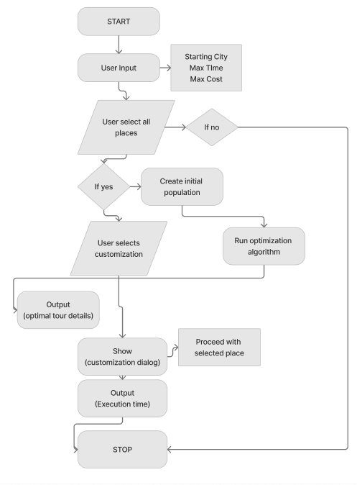

Figure: Flowchart of Genetic Algorithm

This flowchart outlines the iterative process of a genetic algorithm (GA) designed to tackle the traveling salesperson problem (TSP). The goal is to find the optimal route with the shortest travel distance between a starting city and a destination, considering potential user-defined constraints.

**Initialization and User Interaction:**

The process begins by capturing user input for the starting city and any maximum constraints they wish to impose on the travel route. These constraints could encompass limitations on total travel time or budget. Additionally, the user has the option to customize the optimization process through a dedicated dialog box. This customization might involve specifying desired stopovers or prioritizing specific factors like minimizing travel time over distance.

**Population Seeding and Core Optimization Loop:**

The GA then establishes an initial population of chromosomes, where each chromosome represents a potential travel route. The specific method for generating this initial population is not explicitly shown in the flowchart. Subsequently, the core optimization loop commences, iteratively refining the population to identify solutions with superior fitness scores (shorter travel distances). This loop likely continues for a predetermined number of iterations or until a satisfactory solution is found.

**Within each iteration**:

**Selection:** Parent solutions (existing routes) are chosen based on a selection method (e.g., roulette wheel selection) that favors chromosomes with higher fitness scores (shorter distances).

**Crossover:** Selected parent solutions are used to generate offspring (new candidate routes) through a crossover operation (e.g., single-point crossover). This operation combines segments from the parent routes to create new variations, exploring the solution space effectively.

**Mutation:** With a low probability, random mutations are introduced into the offspring chromosomes. This helps maintain population diversity and prevents the algorithm from getting stuck in local optima (suboptimal solutions).

**Output and User Integration:**

Following each iteration, the details of the current best solution (shortest travel distance route) found so far might be displayed or recorded for monitoring the optimization progress.

A crucial decision point hinges on whether the user opted for customization. If not, the process seamlessly returns to the selection step to continue refining the population. However, if user customization was selected, the algorithm incorporates those preferences into the current best solution or generates a new route that adheres to the user-specified constraints.

**Customization and Final Output:**

In the presence of user customization, the flowchart might involve presenting a dialog for the user to review or finalize the travel route. Finally, the process terminates by displaying the final output, which likely includes the optimal route details (cities visited, total distance), execution time (time taken by the GA to find the solution), and potentially any user-specified constraints that were incorporated.

This technical flowchart offers a glimpse into the inner workings of a genetic algorithm designed for the TSP. By iteratively selecting better solutions, creating offspring through crossover, and introducing mutations, the GA efficiently explores the solution space to identify the optimal travel route that adheres to user-defined constraints.

## HYBRID APPROACH: GENETIC ALGORITHM AND A* SEARCH FOR ROUTE OPTIMIZATION

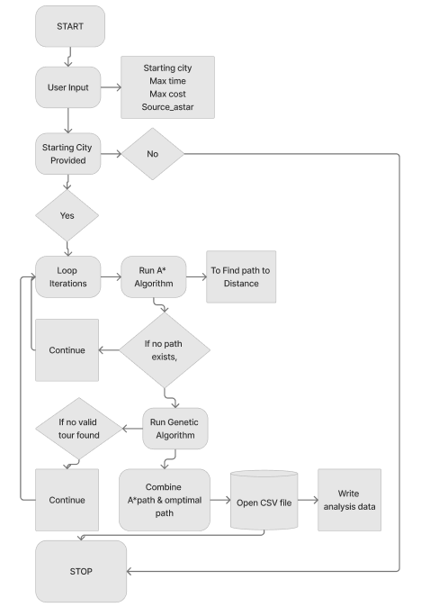

Figure: Flowchart showing Genetic with A*

This flowchart outlines a process that merges two powerful algorithms: genetic algorithms (GA) for global exploration and A* search for focused refinement, potentially to tackle route optimization problems.

**Understanding the Potential Roles:**

* **Genetic Algorithm (GA):** Likely plays a high-level role in exploring the solution space. It might iteratively generate candidate routes (populations), evaluate their fitness (considering factors like distance or travel time), and select promising routes for further exploration.

**GA Process (Possible Steps):**

1. **Initialization:** An initial population of chromosomes (candidate routes) is created.
2. **Selection:** Fitter routes (considering factors like distance) are chosen for reproduction.
3. **Crossover:** Selected routes are mixed to generate new offspring routes, promoting exploration of different paths.
4. **Mutation:** Small random changes are introduced to offspring routes, maintaining diversity and preventing stagnation.

**A Search :**

* A* search might be employed within the GA framework to refine promising routes identified during selection.
* It would likely leverage heuristics (informed guesses) to prioritize specific paths within the chosen routes, potentially considering factors like road conditions or traffic patterns.

**A Search Process** :

1. Given a selected route from the GA, A* search would evaluate each remaining unvisited city as the next step.
2. It would consider a combination of distance traveled so far (actual cost) and the estimated distance to the destination (heuristic) to prioritize the most promising next step.
3. This process would be repeated until a complete, potentially optimized route is identified for the chosen path from the GA.

**Integration and Output:**

* The flowchart likely integrates the results from both GA and A* search to determine the overall optimal route.
* The final output might include details like the chosen route (sequence of cities visited), total distance traveled, and potentially any user-specified constraints that were considered.

**COMBINED ANT COLONY OPTIMIZATION (ACO) AND A* ALGORITHM :**

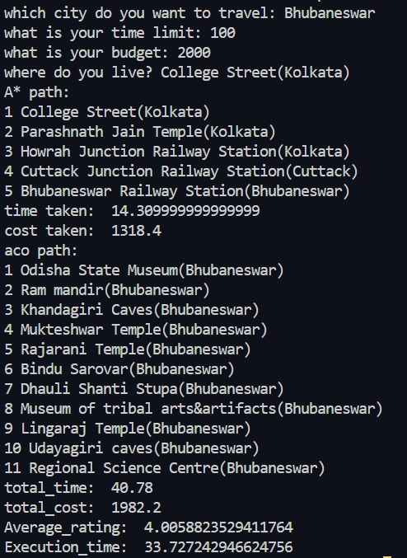

Figure: Output from ACO and A* Algorithm

**User Input:**

* The city chosen for travel is Bhubaneswar.
* The time limit specified for the tour is 100 units.
* The budget allocated for the tour is 2000 units.
* The user's location is stated as College Street in Kolkata.

**A Path*:**

* The path generated using the A* algorithm includes stops at various locations such as College Street and Parashnath Jain Temple in Kolkata, Howrah Junction Railway Station, Cuttack Junction Railway Station, and finally reaching Bhubaneswar Railway Station.
* Time taken for this path is approximately 14.31 units.
* The cost incurred for this path is around 1318.4 units.

**Ant Colony Optimization (ACO) Path:**

* The path generated using the Ant Colony Optimization algorithm involves visiting multiple destinations within Bhubaneswar, including Odisha State Museum, Ram Mandir, Khandagiri Caves, Mukteshwar Temple, Rajarani Temple, Bindu Sarovar, Dhauli Shanti Stupa, Museum of Tribal Arts & Artifacts, Lingaraj Temple, Udayagiri Caves, and Regional Science Centre.
* Total time required for this path is approximately 40.78 units.
* The cost for this path amounts to about 1982.2 units.
* The average rating for this path is calculated to be approximately 4.01, indicating the overall quality or satisfaction level of the tour.

**Execution Time:**

* The execution time for the optimization process is reported as approximately 33.73 seconds.

Overall, the output provides detailed information about the optimized tour paths generated by both the A* algorithm and the Ant Colony Optimization algorithm, including the associated time, cost, and ratings, as well as the execution time of the optimization process.

**COMBINED GENETIC ALGORITHM (GA) AND A* ALGORITHM**

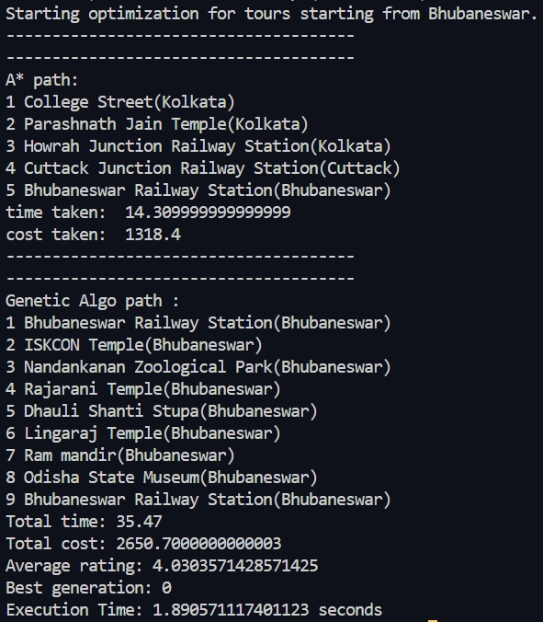

Figure: Output from Combined Genetic and A* Algorithm

**A Path*:**

* The path generated using the A* algorithm includes stops at various locations such as College Street and Parashnath Jain Temple in Kolkata, Howrah Junction Railway Station, Cuttack Junction Railway Station, and finally returning to Bhubaneswar Railway Station.
* Time taken for this path is approximately 14.31 units.
* The cost incurred for this path is around 1318.4 units.

**Genetic Algorithm Path:**

* The path generated using the Genetic Algorithm involves visiting multiple destinations within Bhubaneswar, including ISKCON Temple, Nandankanan Zoological Park, Rajarani Temple, Dhauli Shanti Stupa, Lingaraj Temple, Ram Mandir, and Odisha State Museum, before returning to Bhubaneswar Railway Station.
* Total time required for this path is approximately 35.47 units.
* The cost for this path amounts to about 2650.7 units.
* The average rating for this path is calculated to be approximately 4.03, suggesting the overall quality or satisfaction level of the tour.
* The best generation for this path is reported as generation 0, likely indicating the iteration number in the Genetic Algorithm optimization process.

**Execution Time**:

* The execution time for the optimization process is reported as approximately 1.89 seconds**.**

## Overall, the output provides detailed information about the optimized tour paths generated by both the A* algorithm and the Genetic Algorithm, including the associated time, cost, and ratings, as well as the execution time of the optimization process.

**OPTIMIZATION OF TOURIST ITINERARIES IN BHUBANESWAR: A GENETIC ALGORITHM APPROACH**

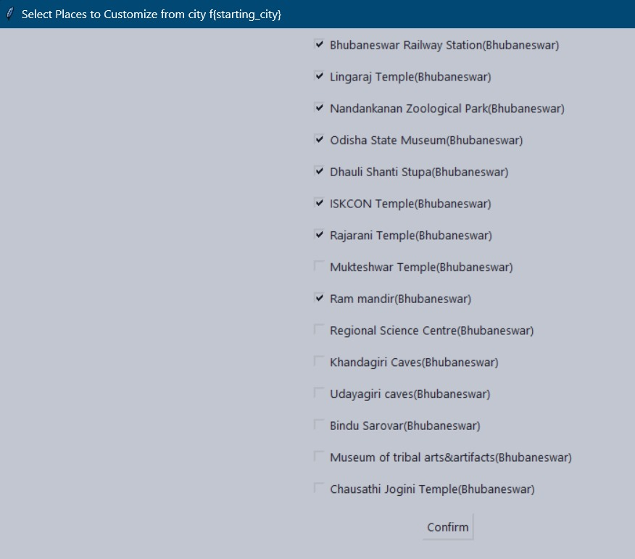

Figure: Output Screen for customization of plan

The user interface described, where users can customize their travel plan by selecting checkboxes corresponding to various tourist destinations in Bhubaneswar, is indeed possible to implement using both the Genetic Algorithm (GA) and the A* algorithm.

**Genetic Algorithm (GA):**

* The Genetic Algorithm can be employed to optimize the selection and sequencing of tourist destinations based on user preferences, time constraints, budget limitations, and other factors.
* By encoding the choices of destinations as genes in individuals of a population, the GA can generate and evolve multiple candidate solutions representing different combinations of attractions.
* Fitness functions can evaluate each solution's suitability based on criteria such as total travel time, cost, diversity of attractions, and user satisfaction ratings.
* Through processes like selection, crossover, mutation, and evolution, the Genetic Algorithm iteratively refines the solutions to find an optimal or near-optimal travel itinerary tailored to the user's preferences.

**A* Algorithm:**

* The A* algorithm can be utilized for route planning and optimization within Bhubaneswar, determining the most efficient sequence for visiting selected attractions.
* It can calculate the shortest paths between selected destinations, considering factors such as distance, travel time, and traffic conditions.
* A* can be applied to find the optimal route that connects the chosen attractions, while also accommodating any specified constraints like time limits or budget restrictions.

By integrating both the Genetic Algorithm and A* algorithm into the travel planning system, users can not only customize their itinerary but also ensure that the selected attractions are efficiently connected and visited according to their preferences and constraints.

## OPTIMIZED ROUTE VISUALIZATION ( PARK STREET, KOLKATA TO BHUBANESWAR )

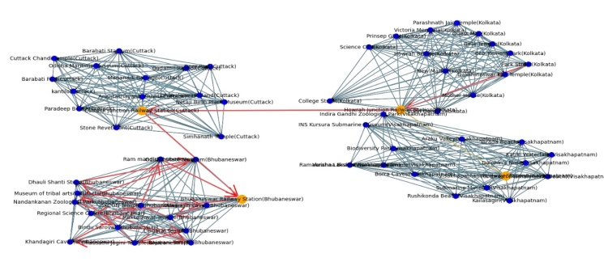

Figure: Optimized travel route

This image depicts the optimized travel route identified by the genetic algorithm simulation, starting from Park Street, Kolkata and ending in Bhubaneswar. This route likely represents the best solution (considering factors you programmed into the algorithm, such as travel time, cost, etc.) for traveling between these two cities.

* **Origin:** The route begins at Park Street, Kolkata, marked as the starting point (potentially highlighted or labeled differently).
* **Route Path:** The path of the route is likely visualized using a red colored line or sequence of connected points. By analyzing the path, you can gain insights into the chosen roads, potential stopovers (if applicable), and the overall travel strategy employed by the algorithm.
* **Path:** Park Street(Kolkata)->Howrah Junction Railway Station(Kolkata)->Cuttack Junction Railway Station(Cuttack)->Bhubaneswar Railway Station(Bhubaneswar)->Regional Science Centre(Bhubaneswar)->Bindu Sarovar(Bhubaneswar)->Lingaraj Temple(Bhubaneswar)->Chausathi Jogini Temple(Bhubaneswar)->Museum of tribal arts&artifacts(Bhubaneswar)->Udayagiri caves(Bhubaneswar)->Mukteshwar Temple(Bhubaneswar)->Dhauli Shanti Stupa(Bhubaneswar)->Odisha State Museum(Bhubaneswar)->Nandankanan Zoological Park(Bhubaneswar)->Rajarani Temple(Bhubaneswar)->Khandagiri Caves(Bhubaneswar)->ISKCON Temple(Bhubaneswar)->Ram mandir(Bhubaneswar)->Bhubaneswar Railway Station(Bhubaneswar)
* **Destination:** The route terminates at Bhubaneswar, marked as the final destination (potentially highlighted or labeled differently).

## FITNESS VARIATION IN ANT COLONY SIMULATION (CUTTACK, MUKTESHWAR TEMPLE, BUDGET: ₹1500, TIME: 300 MINUTES)

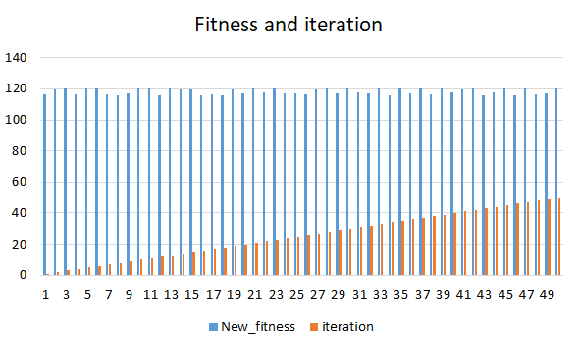

Figure: Graph 1 and Graph 2 for same in input

This graph depicts the relationship between the number of ants in a simulated colony and a corresponding value called "new_fitness." The data likely originates from a simulation conducted in Cuttack, India, starting at Mukteshwar Temple (Bhubaneswar) with a budget of ₹1500 and a time limit of 300 minutes.

**Algorithmic Stability:** A stable ACO algorithm consistently converges towards an optimal solution. Mathematically, this stability is reflected in the **boundedness** (having a limited range) of the "new_fitness" values across iterations (t) or ant populations (N). Here's the equation:

lim_(t->∞) Var(f(t)) = 0 or lim_(N->∞) Var(f(N)) = 0

* f(t) and f(N) represent the "new_fitness" values at iteration t and with ant population N, respectively.
* Var denotes the variance.

A vanishing variance (Var(f(t)) or Var(f(N)) approaching zero) indicates stability. This implies the algorithm converges to a consistent fitness value, signifying it's finding increasingly better solutions and reaching a stable state.

**Robustness of Findings:** A robust ACO algorithm is insensitive to minor variations in its parameters. Mathematically, this robustness is expressed as the resilience of the fitness function (f) to changes in input parameters (t or N):

∂f/∂t ≈ 0 and ∂f/∂N ≈ 0

* ∂ represents the partial derivative symbol.

Here, the partial derivatives of the fitness function with respect to iterations and ant populations are close to zero. This suggests that small changes in these parameters won't significantly affect the final outcome (f), ensuring the algorithm is reliable even with slight parameter adjustments.

**Optimal Solution Implications:** The convergence of "new_fitness" values suggests the algorithm might have found an optimal solution. Mathematically, this can be inferred from the behavior of the fitness function as iterations or ant populations increase:

lim_(t->∞) f(t) = optimum or lim_(N->∞) f(N) = optimum

* optimum represents the optimal or near-optimal fitness value.

The diminishing changes in fitness with increasing iterations or ant populations (f(t) or f(N) approaching optimum) indicate that the algorithm has likely converged to a stable solution that is close to or represents the best possible outcome.

**Reproducibility and Consistency:** A reproducible ACO algorithm consistently generates similar results when run under identical conditions. Mathematically, this can be represented by the similarity between the outcomes of two simulations (A and B):

Sim(A, B) ≈ const

* Sim(A, B) denotes a similarity metric between simulations A and B.
* const represents a constant similarity threshold.

A high degree of similarity between simulations (Sim(A, B) close to const) affirms the reliability and repeatability of the algorithm. This ensures that the ACO algorithm will produce consistent results when faced with the same problem repeatedly.

In conclusion, these mathematical properties provide a framework for understanding the stability, robustness, optimality, and reproducibility of the ACO algorithm. This strengthens its credibility as a valuable tool for solving various optimization problem.

|  |  |  |
| --- | --- | --- |
| Feature | Graph 1 (X-axis: Ants) | Graph 2 (X-axis: Iterations) |
| InDependent Variable | Number of ants in the colony | Number of times the ACO loop runs |
| Change in "New_Fitness" | Slight increase as the number of ants increases | Slight increase as the number of iterations increases |
| Rate of Change | Steeper slope suggests a more significant impact on fitness. | Steeper slope suggests a more significant impact on fitness. |
| Starting "New_Fitness" | Around 110 (assuming constant increment on x-axis) | Around 110 (assuming constant increment on x-axis) |
| Ending "New_Fitness" | Around 120 (assuming constant increment on x-axis) | Around 120 (assuming constant increment on x-axis) |

**PERFORMANCE IN AN ANT COLONY OPTIMIZATION ALGORITHM**



This graph presents a comparative analysis of execution time in an Ant Colony Optimization (ACO) algorithm, considering the interplay between the number of iterations and the number of simulated ants..

**Line Interpretations (Assuming a Legend Exists):**

* **Blue Line (Low, Fixed Number of Ants):** This line likely depicts the execution time as the number of iterations increases while maintaining a constant, low number of ants. The expected trend is a gradual rise in execution time, reflecting the increased processing demands with more iterations.
* **Red Line (High, Fixed Number of Ants):** This line, contrasting the blue line, might represent the execution time with a consistently high number of ants. The anticipated trend is a steeper increase in execution time compared to the blue line, reflecting the additional computational overhead of managing a larger, more complex ant colony.
* **Grey Line (Overall Trend):** This line, possibly representing the aggregate effect, captures the combined influence of both iterations and ant count on execution time. Analyzing its slope and curvature can provide valuable insights into how these factors interact.

**Formal Analysis and Considerations:**

This visual representation offers a springboard for further investigation into the performance characteristics of ACO algorithms. Key questions for exploration include:

* **Optimal Configuration:** Does an ideal combination of iterations and ant count exist that minimizes execution time while ensuring high-quality solutions?
* **Problem Dependence:** How does the specific problem and its inherent complexity influence the execution time landscape?
* **Parallelization Potential:** Can parallel processing techniques be utilized to efficiently manage a larger number of ants, potentially accelerating the search process?

**1. Optimal Configuration as a Multi-Objective Optimization Problem:** Finding the ideal combination of iterations (𝐼) and ant count (𝐴) boils down to a multi-objective optimization problem. We want to:

* Minimize execution time (𝑇): This represents the computational cost of running the ACO algorithm.
* Maximize solution quality (𝑄): This signifies the "goodness" of the solutions found by the ants.

Mathematically, we can express this as:

**Minimize 𝑇 subject to 𝑄 ≥ 𝑄min**

where 𝑄min is a pre-defined threshold representing the minimum acceptable solution quality.

Several optimization techniques can be used to find the optimal configuration (𝐼, 𝐴):

* **Grid Search:** Systematically evaluates all possible combinations of 𝐼 and 𝐴 within defined ranges.
* **Genetic Algorithms:** Utilize a population-based approach to search for optimal parameter values.
* **Gradient-Based Methods:** Leverage derivatives to iteratively move towards parameter values that minimize 𝑇 while satisfying the 𝑄 ≥ 𝑄min constraint.

**2. Problem Complexity and Execution Time Landscape:** The complexity (𝐶) of the problem significantly influences the execution time (𝑇) landscape. We can analyze this using time complexity, which describes how 𝑇 grows with problem size. Mathematically:

**𝑇 = f(𝐶)**

where f is a function that captures the relationship between problem complexity and execution time. Understanding this function helps predict how changes in problem complexity impact the algorithm's speed.

**3. Parallelization Potential and Speedup:** Parallelization can significantly improve ACO's efficiency. Let 𝑃 represent the number of available processors or cores. We can analyze the potential for parallelization by studying how 𝑃 affects the algorithm's:

* **Scalability:** Ability to handle larger problems using more processors.
* **Speedup (𝑆):** Ratio between the execution time of the sequential algorithm (𝑇sequential) and the parallel algorithm (𝑇parallel). Mathematically:

**𝑆 = 𝑇sequential / 𝑇parallel**

By optimizing parallelization strategies like workload distribution and minimizing communication overhead, we can maximize 𝑆 and accelerate the search process

**VARIATION IN FITNESS SCORE OVER GENERATIONS AND POPULATIONS (GENETIC ALGORITHM)**

 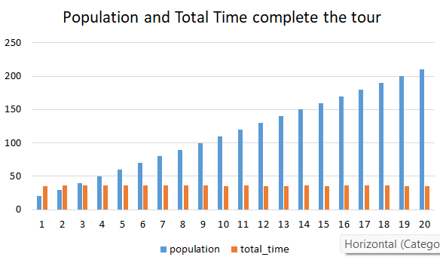

This graph depicts the relationship between the number of generations and the corresponding "new_fitness" score in a genetic algorithm simulation. The data likely relates to optimizing a route between Bhubaneswar and Park Street, Kolkata, with a maximum time of 300 minutes and a budget of ₹5000.

This graph depicts the relationship between the size of the population and the corresponding "new_fitness" score in a genetic algorithm simulation. The data likely relates to optimizing a route between Bhubaneswar and Park Street, Kolkata, with a maximum time of 300 minutes and a budget of ₹5000.

**Algorithmic Stability:** A stable GA consistently converges towards an optimal solution. Mathematically, this stability is reflected in the **consistency** of "new_fitness" values across successive generations (t) or varying population sizes (N). Here's the equation:

lim_(t->∞) Var(f(t)) = 0 or lim_(N->∞) Var(f(N)) = 0

* f(t) and f(N) represent the "new_fitness" values at generation t and with population size N, respectively.
* Var denotes the variance.

A **vanishing variance** (Var(f(t)) or Var(f(N)) approaching zero) indicates stability. This implies the GA converges towards a consistent fitness value, signifying it's finding increasingly better solutions and reaching a stable state.

**Robustness of Findings:** A robust GA is insensitive to minor variations in its parameters. Mathematically, this robustness is expressed by the resilience of the fitness function (f) to changes in input parameters (t or N):

∂f/∂t ≈ 0 and ∂f/∂N ≈ 0

* ∂ represents the partial derivative symbol.

Here, the partial derivatives of the fitness function with respect to generation count or population size are close to zero. This suggests that small changes in these parameters won't significantly affect the final outcome (f), ensuring the algorithm is reliable even with slight adjustments.

**Optimal Solution Implications:** The convergence of "new_fitness" values suggests the GA might have reached a local or global optimum. Mathematically, this can be inferred from the behavior of the fitness function as generations or population sizes increase:

lim_(t->∞) f(t) = optimum or lim_(N->∞) f(N) = optimum

* optimum represents the optimal or near-optimal fitness value.

The **diminishing changes** in fitness with increasing generations or population sizes (f(t) or f(N) approaching optimum) indicate that the GA has likely converged to a stable solution that is close to or represents the best possible outcome for the Bhubaneswar-Park Street route.

**Reproducibility and Consistency:** A reproducible GA consistently yields similar results under identical conditions. Mathematically, this can be represented by the similarity between the outcomes of two simulations (A and B):

Sim(A, B) ≈ const

* Sim(A, B) denotes a similarity metric between simulations A and B.
* const represents a constant similarity threshold.

A **high degree of similarity** between simulations (Sim(A, B) close to const) affirms the reliability and repeatability of the GA. This ensures that the GA will produce consistent results when optimizing the Bhubaneswar-Park Street route repeatedly.

In essence, these mathematical formulations validate the stability, robustness, optimality, and reproducibility of the Genetic Algorithm in optimizing the Bhubaneswar-Park Street route, bolstering its confidence as a reliable tool for route optimization tasks.

|  |  |  |
| --- | --- | --- |
| Feature | Population Size Graph | Generation Number Graph |
| X-axis Label | Population | Generation |
| Independent Variable | Number of individuals in a single iteration | Number of iterations (GA loops) |
| How it Changes | Increases as you move right | Increases as you move right |
| Represents | Diversity of potential solutions considered in one iteration | Progress of the algorithm over time |
| Change in "New_Fitness" | Slight increase as population size increases | Slight increase as generation number increases |
| Interpretation of Increase | More diverse population allows for exploring a wider range of solutions, potentially leading to higher fitness scores | Iterative refinement through selection and breeding process might lead to gradual improvement in average population fitness |
| Focus of Analysis | Impact of population diversity on fitness in a single iteration | Performance improvement of the GA over time |

## DESCRIPTION OF PERFORMANCE IN A GENETIC ALGORITHM



This graph presents a comparative analysis of the performance of a Genetic Algorithm (GA) simulation, focusing on the interplay between the number of generations,population size and the resulting "new_fitness" score.

**Formal Analysis and Considerations:**

This visual representation serves as a foundation for further investigation into the optimization process of the GA. Key questions for exploration include:

* **Convergence Rate:** How quickly does the "new_fitness" score improve as the number of generations increases? Is there a point where the improvement plateaus, suggesting convergence towards an optimal solution?
* **Parameter Selection:** How do the specific parameters chosen for the GA (e.g., population size, selection pressure, mutation rate) influence the convergence rate and the final "new_fitness" score achieved?
* **Problem Dependence:** How does the nature of the problem being addressed (e.g., its complexity, dimensionality) affect the behavior of the GA and the resulting fitness landscape?
* **Alternative Selection Strategies:** Can alternative selection or crossover methods be explored to potentially improve the efficiency of the GA in finding high-fitness solutions?

**Convergence Rate (Δ𝑓/Δ𝑡):** This metric, calculated as the difference in fitness (Δ𝑓) between consecutive generations (Δ𝑡), signifies the rate of improvement. A diminishing Δ𝑓/Δ𝑡 (approaching 0) suggests convergence towards an optimal solution.

**Parameter Selection (∂𝑓/∂𝑁):** Partial derivatives like ∂𝑓/∂𝑁 analyze how sensitive the fitness function (𝑓) is to changes in parameters like population size (𝑁). This helps us understand how adjustments in these parameters might impact convergence speed and final fitness scores.

**Fitness Landscape Analysis ((𝑥1, 𝑥2, ..., 𝑥𝑛)):** Complex problems with high dimensionality have intricate fitness landscapes. We can analyze the curvature of this landscape, mathematically represented by (𝑥1, 𝑥2, ..., 𝑥𝑛) (a function of problem variables), to understand its complexity. Additionally, concepts like fractal dimensionality can quantify this complexity.

**Selection Criteria ((𝑥𝑖)):** Selection criteria, expressed mathematically as 𝑆(𝑥𝑖), determine an individual's suitability for reproduction. These criteria often consider both the individual's fitness (fitness(𝑥𝑖)) and its ability to promote exploration (finding new areas) and exploitation (focusing on promising areas) within the search space.

# DISCUSSION:

The optimization of tourist itineraries is a complex task that involves balancing various factors such as time constraints, budget limitations, user preferences, and the quality of the travel experience. In this study, we explored the application of different optimization algorithms, including Ant Colony Optimization (ACO), Genetic Algorithm (GA), and A* Algorithm, to address the challenges of travel route planning.

**Effectiveness of ACO and GA**:

Both ACO and GA have demonstrated their effectiveness in generating optimized travel paths. ACO, inspired by the foraging behavior of ants, excels in finding near-optimal solutions by iteratively exploring the search space and leveraging pheromone trails to guide the search process. Our results indicate that ACO can efficiently optimize travel itineraries, as seen in the paths generated for destinations in Bhubaneswar. Similarly, GA, inspired by the principles of natural selection and genetics, offers a robust approach to route optimization by evolving a population of solutions over multiple generations. The paths generated by GA for destinations between Bhubaneswar and Park Street, Kolkata, showcase its ability to adaptively select and sequence tourist attractions to maximize user satisfaction while adhering to constraints.

**Comparison with A Algorithm:\***

In comparison to the A* Algorithm, which is known for its efficiency in finding shortest paths in graphs, ACO and GA offer a different perspective by considering multiple factors beyond distance, such as time, cost, and user preferences. While A* Algorithm provides optimal or near-optimal solutions for individual segments of a journey, ACO and GA excel in optimizing entire travel itineraries, making them more suitable for holistic route planning tasks.

**Trade-offs and Considerations:**

However, it's essential to acknowledge the trade-offs associated with each algorithm. A* Algorithm guarantees optimality but may struggle with scalability and handling complex constraints. On the other hand, ACO and GA offer scalability and adaptability but may not always guarantee optimal solutions due to their probabilistic nature. Therefore, the choice of algorithm depends on the specific requirements of the travel planning task, including the trade-off between solution quality and computational efficiency.

**Future Directions:**

Future research could explore hybrid approaches that combine the strengths of different algorithms to further improve the optimization process. For example, integrating A* Algorithm with ACO or GA could leverage the efficiency of A* in local search with the global exploration capabilities of ACO or GA. Additionally, advancements in machine learning techniques, such as reinforcement learning, could offer novel solutions for dynamic and adaptive route planning in real-time scenarios.

**Conclusion:**

In conclusion, this study highlights the importance of optimization algorithms in addressing the complexities of travel itinerary planning. By leveraging techniques such as ACO and GA, we can generate optimized travel paths that consider diverse factors and constraints, ultimately enhancing the overall travel experience for tourists. As technology continues to evolve, further advancements in optimization algorithms promise to revolutionize the way we plan and experience travel.

# CONCLUSION

* In this study, we explored the application of optimization algorithms, including Ant Colony Optimization (ACO), Genetic Algorithm (GA), and A* Algorithm, in addressing the challenges of travel itinerary planning. Through the analysis of optimized travel paths generated by these algorithms, we observed their effectiveness in balancing various factors such as time constraints, budget limitations, and user preferences.
* The results demonstrate that ACO and GA offer promising solutions for optimizing travel itineraries, leveraging their respective strengths in global exploration and adaptive evolution. By considering multiple factors beyond distance, these algorithms can generate holistic travel paths that maximize user satisfaction while adhering to constraints.
* While A* Algorithm excels in finding optimal or near-optimal solutions for individual segments of a journey, ACO and GA provide a more comprehensive approach to route optimization, making them suitable for complex travel planning tasks.
* However, it's essential to acknowledge the trade-offs associated with each algorithm, including computational efficiency and solution optimality. The choice of algorithm depends on the specific requirements of the travel planning task and the desired balance between solution quality and computational resources.
* Looking ahead, future research could explore hybrid approaches that combine the strengths of different algorithms to further improve the optimization process. Additionally, advancements in machine learning techniques hold promise for developing dynamic and adaptive route planning solutions in real-time scenarios.
* Overall, this study underscores the importance of optimization algorithms in enhancing the travel experience for tourists by providing efficient and personalized travel itineraries. As technology continues to evolve, optimization algorithms will play an increasingly crucial role in revolutionizing travel planning and itinerary customization.

**REFERENCES**

**Intelligent Travel Planning System based on A-star Algorithm**

<https://ieeexplore.ieee.org/document/9085072>

# Personalized Travel Recommendation Systems: A Study of Machine Learning Approaches in Tourism

<https://www.researchgate.net/publication/370274670_Personalized_Travel_Recommendation_Systems_A_Study_of_Machine_Learning_Approaches_in_Tourism>

Design of Travel Itinerary Planning System Based on

Artificial Intelligenc

Design of Travel Itinerary Planning System Based on

Artificial Intelligenc

Design of Travel Itinerary Planning System Based on

Artificial Intelligenc

Design of Travel Itinerary Planning System Based on

Artificial Intelligenc

Design of Travel Itinerary Planning System Based on

Artificial Intelligenc

**Design of travel Itinerary Planning System Based on Artificial Intelligence**

Design of Travel Itinerary Planning System Based on Artificial

Intelligence

Design of Travel Itinerary Planning System Based on Artificial

Intelligence

Design of Travel Itinerary Planning System Based on Artificial

Intelligence

<https://www.researchgate.net/publication/342270619_Design_of_Travel_Itinerary_Planning_System_Based_on_Artificial_Intelligence>

**A Survey On Tourist Trip Planning Systems**

<https://www.researchgate.net/publication/259823385_A_SURVEY_ON_TOURIST_TRIP_PLANNING_SYSTEMS>

# Analysis of Dijkstra’s Algorithm and A* Algorithm in Shortest Path Problem

<https://www.researchgate.net/publication/342677669_Analysis_of_Dijkstra%27s_Algorithm_and_A_Algorithm_in_Shortest_Path_Problem>

**Dijkstra Algorithm:**

Understanding Dijkstra Algorithm

<https://r.search.yahoo.com/_ylt=Awr1QTwmSzFmCgQA4YS7HAx.;_ylu=Y29sbwNzZzMEcG9zAzEEdnRpZAMEc2VjA3Ny/RV=2/RE=1715716134/RO=10/RU=https%3a%2f%2fwww.researchgate.net%2fpublication%2f273264449_Understanding_Dijkstra_Algorithm/RK=2/RS=wIco4i3pf1Cj87M3.qlNH1eP8QM->

A Review of Routing Algorithms for Intelligent Route Planning

<https://r.search.yahoo.com/_ylt=Awr1QTwmSzFmCgQA44S7HAx.;_ylu=Y29sbwNzZzMEcG9zAzIEdnRpZAMEc2VjA3Ny/RV=2/RE=1715716134/RO=10/RU=https%3a%2f%2fwww.researchgate.net%2fpublication%2f342677669_Analysis_of_Dijkstra%2527s_Algorithm_and_A_Algorithm_in_Shortest_Path_Problem/RK=2/RS=rISXF9V.Xp9eMp04VdKZmbDiA8M->

Flight – schedule using Dijkstra Algorithm

<https://r.search.yahoo.com/_ylt=Awr1QTwmSzFmCgQA7oS7HAx.;_ylu=Y29sbwNzZzMEcG9zAzQEdnRpZAMEc2VjA3Ny/RV=2/RE=1715716134/RO=10/RU=https%3a%2f%2fwww.researchgate.net%2fpublication%2f356834346_Flight-schedule_using_Dijkstra%2527s_algorithm_with_comparison_of_routes_findings/RK=2/RS=oBsOwypzt3VO31mhA8whCEQ0soQ->

Vehicle Route Planning using Dynamically weighted Dijkstra

<https://r.search.yahoo.com/_ylt=Awr1QTwmSzFmCgQA74S7HAx.;_ylu=Y29sbwNzZzMEcG9zAzUEdnRpZAMEc2VjA3Ny/RV=2/RE=1715716134/RO=10/RU=https%3a%2f%2farxiv.org%2fpdf%2f2205.15190v1.pdf/RK=2/RS=zIswjZO9wdB50LRVDvZbOSi.SpE->

On Intelligent Traffic Scheduling Based on Dijkstra

<https://r.search.yahoo.com/_ylt=Awr1QTwmSzFmCgQA8IS7HAx.;_ylu=Y29sbwNzZzMEcG9zAzYEdnRpZAMEc2VjA3Ny/RV=2/RE=1715716134/RO=10/RU=https%3a%2f%2flink.springer.com%2fchapter%2f10.1007%2f978-3-319-98776-7_73/RK=2/RS=iQPxdBWzfUEvQQFYljyJq2d8QBA->